**One day Yuva Vani Orientation Programme organized at GDC Rajpora**

The Department of Horticulture, Agriculture and Animal Husbandry Pulwama organized one day Yuva Vani orientation programme in collaboration with Career Counselling Cell of the college in the Conference Room on 07-12-2023 at 12 noon. The programme was aimed at creating awareness among the students about various self-employment schemes financed by the government and sponsored by the departments of Agriculture, Horticulture and Animal Husbandry.

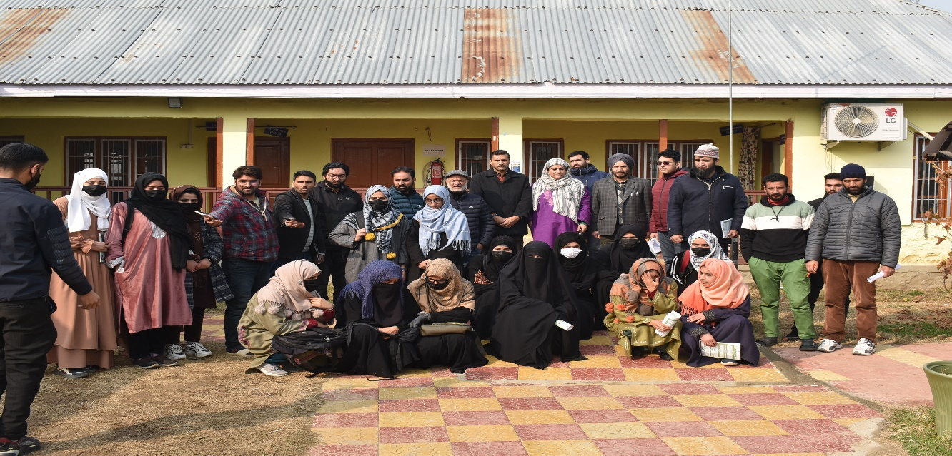

The programme was moderated by Mr. Ajeet Singh, Area Marketing Officer Pulwama. Other dignitaries who spoke on the occasion include Bilal Ahmad Market Inspector, Mohammad Manzoor Horticulture Development Officer Shadimarg, Riyaz Ur Rehman Marketing Inspector Pulwama and Imtiyaz Ali Mir, Assistant Grading Marketing Officer. Principal of the college Prof (Dr) Gazala Gayas in her concluding remarks deliberated on the importance of different Govt. financed schemes including those sponsored by the agriculture and horticulture departments for the college going students.

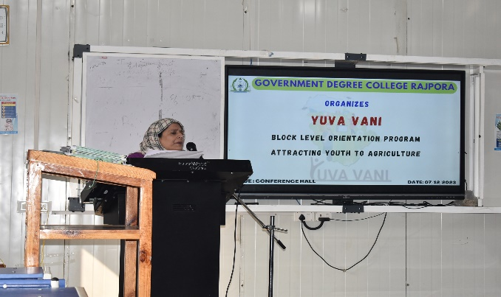 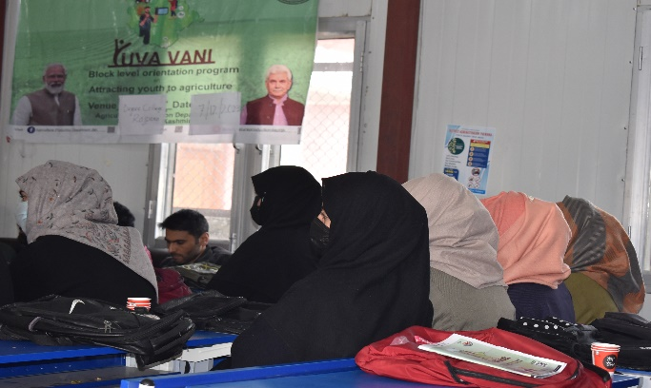

She appreciated the efforts of the guest speakers in sensitizing the youth about these schemes as these schemes provide a hope for the unemployed people to earn their livelihood in a respectable manner in addition to proving job to others in such entrepreneurial organizations.

***Sd/-***

***Principal***

***Govt. Degree College Rajpora***