**Report on cleanliness drive of Washrooms in the college on 08-08-2024**

The Swachhta Pakhwada initiative is a government campaign aimed at promoting cleanliness and hygiene across various sectors. As part of this initiative, GDC Rajpora conducted a cleanliness drive of its washrooms on 08 August 2024 to assess their cleanliness and ensure adherence to hygiene standards. The objectives were to evaluate the cleanliness of the washrooms and identify areas needing improvement. The cleanliness drive under Swachhta Pakhwada has significantly improved the hygiene and sanitation of the washrooms. While most areas were found to be well-maintained, continuous efforts are required to sustain and further enhance these standards. Regular inspections, timely maintenance, and active feedback collection will ensure that the washrooms remain clean and hygienic for all users. Overall, the cleanliness of the washrooms at GDC Rajpora under the Swachhta Pakhwada initiative was satisfactory.

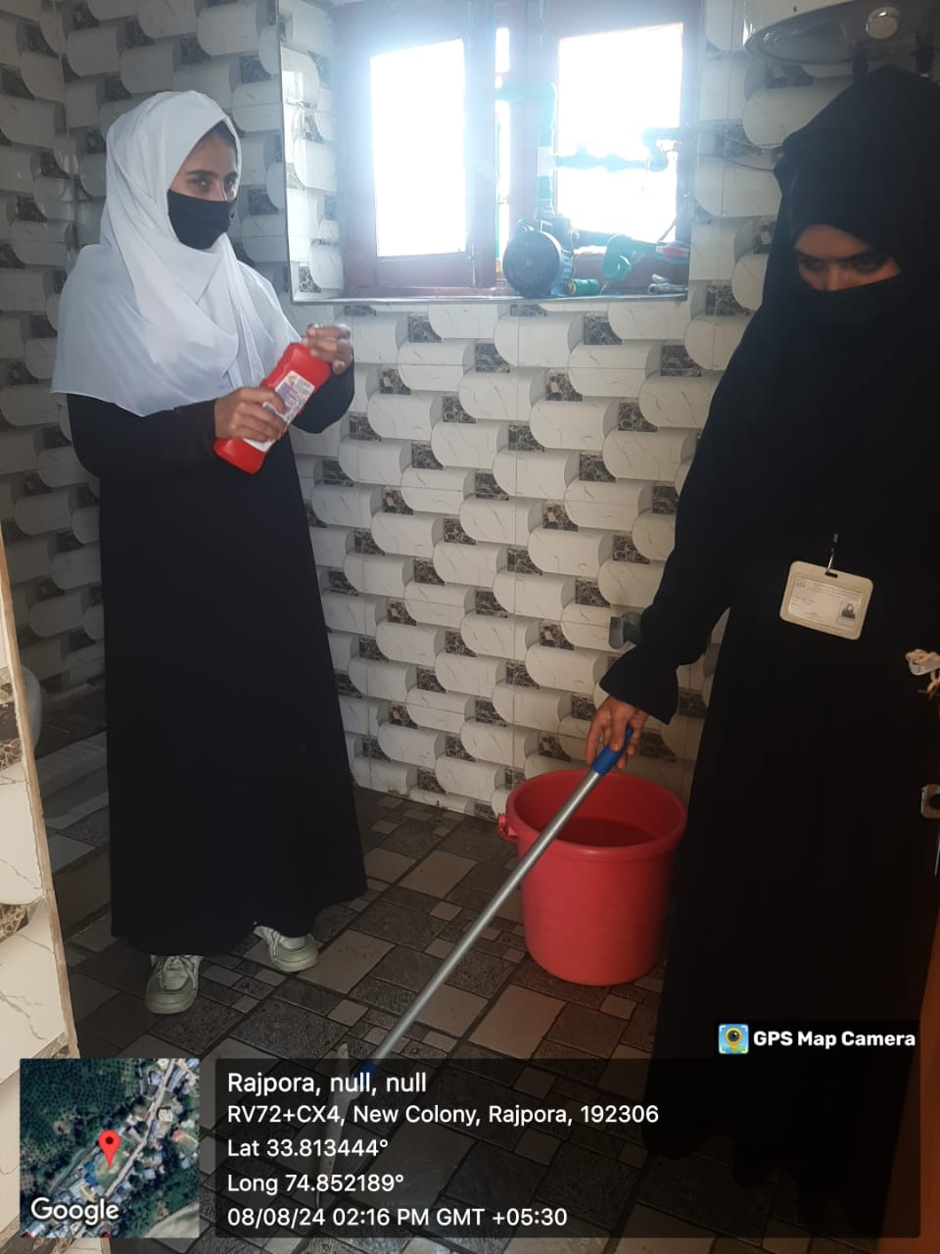 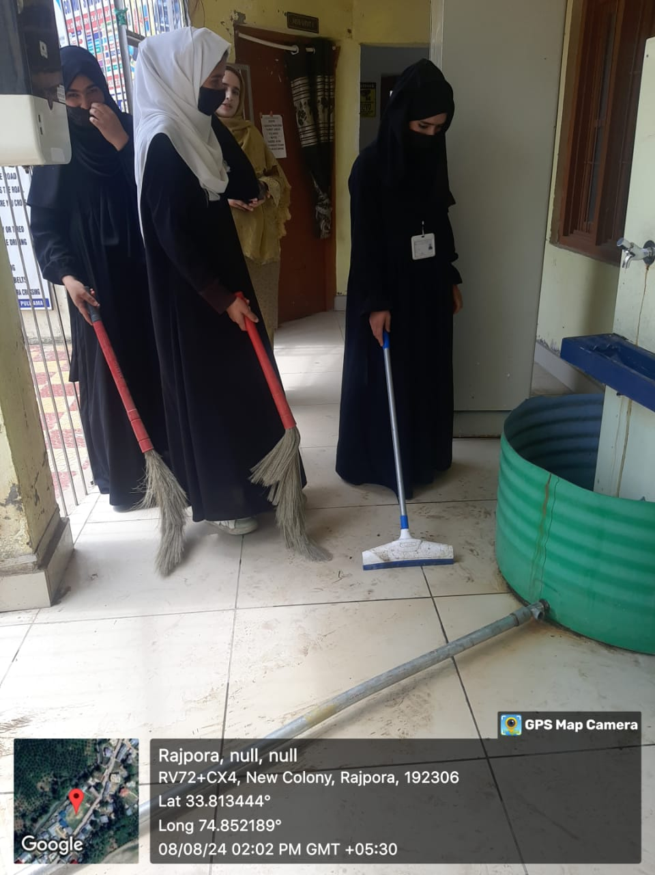

Nodal Officer Principal

Swachhata Pakhwada 2024 Govt. Degree College Rajpora