**PRESS RELEASE**

**Successful Conclusion of 7-Day Online International Faculty Development Program on “Tools and Techniques of AI in Future Research and Higher Education” organised by Internal Quality Assurance cell (IQAC) GDC Rajpora and Cape Comorin Trust, Tamil Nadu India in association with Harvest- An International Multidisciplinary and Multilingual Research Journal**

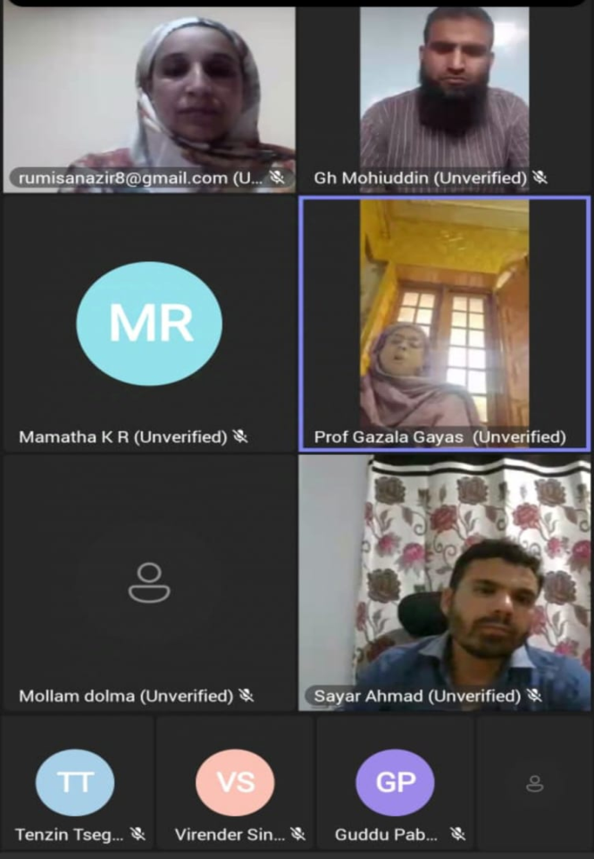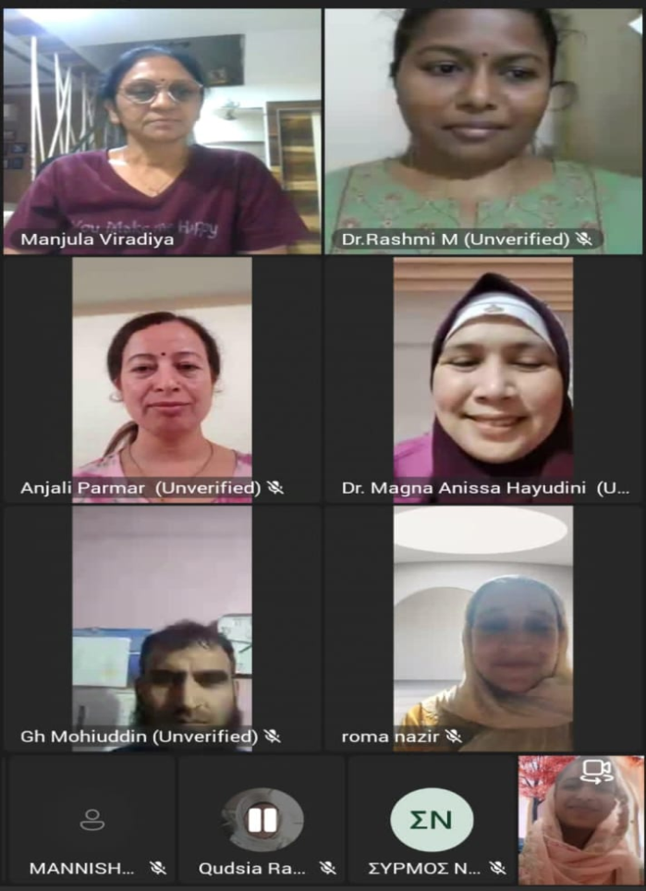GDC Rajpora proudly announces the successful completion of its 7-days online international Faculty Development Program (FDP) on “Tools and Techniques of AI in Future Research and Higher Education” organised by Internal Quality Assurance cell GDC Rajpora and Cape Comorin Trust, Tamil Nadu India in association with Harvest- An International Multidisciplinary and Multilingual Research Journal from 24th to 30th September 2024. The program was a resounding success, bringing together educators and researchers from around the globe to explore the transformative potential of AI in academia.

The online event was inaugurated by Principal GDC Rajpora, Prof. Dr Gazala Gaiyas. In her inaugural address, she emphasized on the use of AI in research development in higher education. She further said that future of research, learning methodologies and even the nature of higher education will be deeply intertwined with advancements in AI. Prof. Ghulam Mohiuddin Andrabi H.O.D English, delivered welcome address. Over 110 participants around the globe participated in the program. Sessions were moderated by Prof. Mohiudin Andrabi, Prof. Nahida shafi, Prof. Ramiz Raja & Prof. Rumisa Nazir. There were engaging sessions on AI-driven methodologies, machine learning applications, and ethical considerations in AI research. Insightful case studies on future trends in AI and education were also discussed.

**Esteemed Speakers for different sessions:**

* **Dr. Azra Tajhizi, from Maragheh university, Iran**
* **Dr. Sudhakar Umale from Thakur college of Engineering, Mumbai**
* **Dr. Ali Azar from university of Malaya, Malaysia**
* **Dr. Rania Lampou from Greek Ministry of Education**
* **Dr. Mohd. Zuber, from Jamia Milia Islamia**
* **Dr. Magna Anissa From Phillipines**
* **Dr. Irfanullah from Afghanistan**
* **Prof. Luis Miguel from University of Lisbon, Portugal**
* **Dr. K. Thiyagu from central university of Kerala**
* **Dr. souvik Ganguly from Thapar Institute of Engineering & Technology, Patiala.**
* **Amd. Dr Assem Abdel Hamied Mousa from Langbustech University, and**
* **Dr. Ruchi Thakur from National Law University Shimla.**

Participants expressed high satisfaction with the program, highlighting the quality of the sessions, the expertise of the speakers, and the practical insights gained. Many participants noted that the FDP provided valuable knowledge and skills that they can apply in their teaching and research activities. Supported by the college management the program was successfully coordinated by **IQAC Coordinator Prof. Rumisa Nazir.**