**Report on beautification of college parks on 09-08-2024**

On August 9, 2024, a significant event focused on the beautification of college parks was held at Government Degree College (GDC) Rajpora as part of the Swachhta Pakhwada initiative. The event aimed to enhance the aesthetic appeal of the college environment and promote cleanliness and greenery on campus. The beautification drive saw active participation from students, faculty members, and non-teaching staff. Its objectives were to enhance the college environment’s aesthetic appeal, promote sustainability, and instill a sense of responsibility among the college community towards maintaining cleanliness and greenery. The event was a resounding success, fostering responsibility among the community for maintaining a clean and healthy environment. This collective effort demonstrated GDC Rajpora’s commitment to the principles of Swachhta Pakhwada, contributing to a more beautiful and sustainable Campus

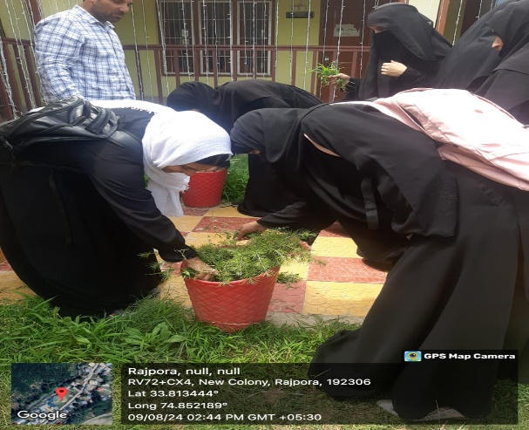 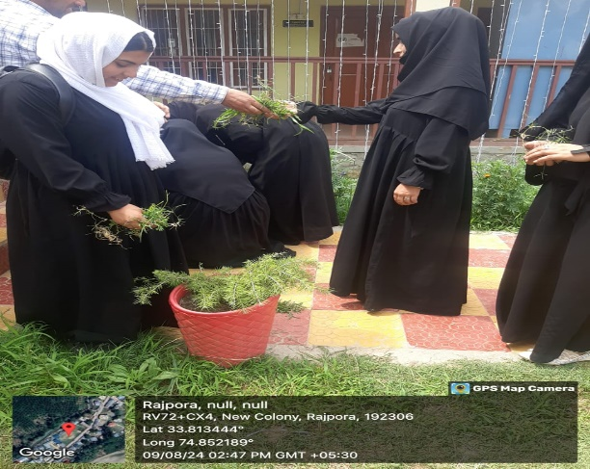

Nodal Officer Principal

Swachhata Pakhwada 2024 Govt. Degree College Rajpora