**National Anthem Singing Competition held at GDC Rajpora on 01-08-2024**

The Debates and Seminar Committee in collaboration with the NSS Unit GDC Rajpora organized **National Anthem Singing Competition** as part of 78th Independence Day celebrations on 01-08-2024 at 1 PM in the Conference Room. A good number of students and staff members attended the function. Students from semester 2nd enthralled the audience with singing of the National Anthem in a melodious voice. It was an interesting session in which the staff and students equally participated. Prof Ramiz Raja and Prof Rumisa Nazir also spoke on the occasion. Miss Munazah from BG 2nd semester was declared as the best presenter of the function. Prof Gh Mohiuddin hosted the proceedings of the event.

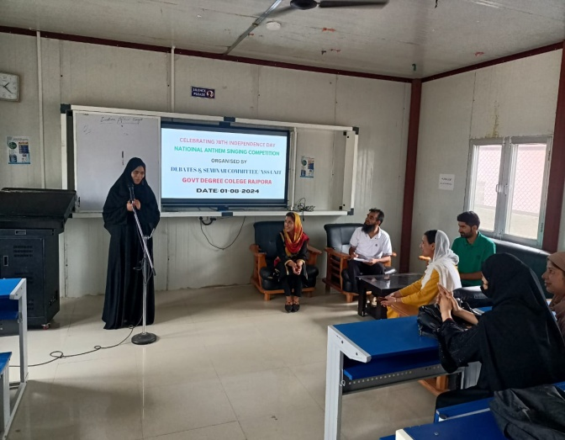 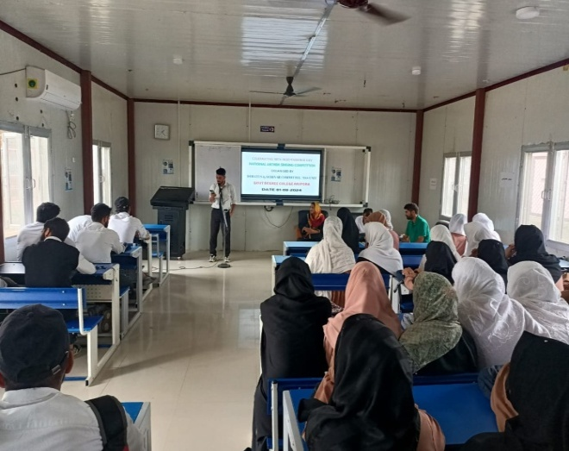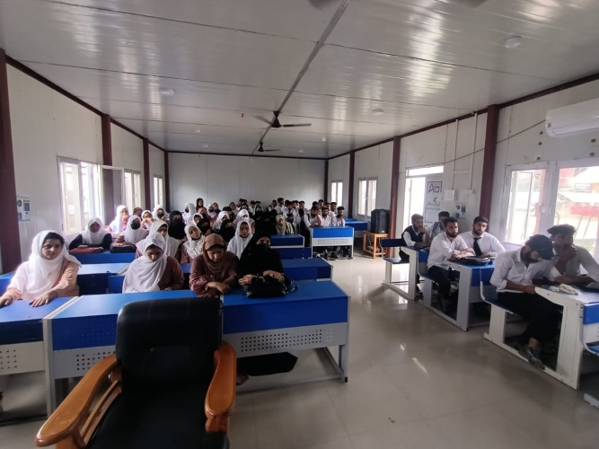 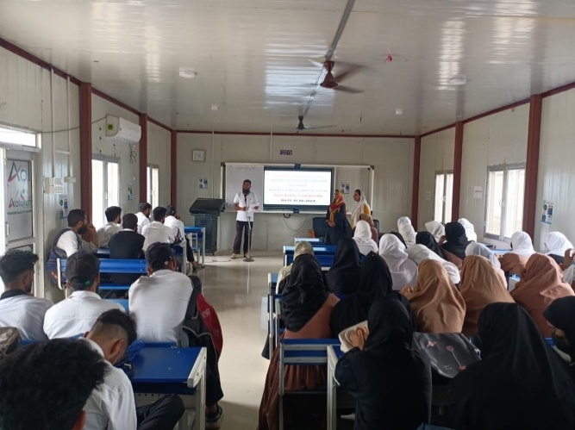

Convener Principal

Debates and Seminar Committee Govt. Degree college Rajpora

**Painting Competition on Independent India held at GDC Rajpora**

The Debates and Seminar Committee in collaborating with NSS Unit Government Degree College Rajpora organized a Quiz Competition on the theme **“Independent India”** on 03-08-2024. As many as eight students designed their paintings on the given theme and displayed their talent. All participants made very impressive paintings depicting different shades of Indian National Heritage. After evaluating the paintings, Syed Tabish from 4th semester was declared as the 1st position holder of the event.

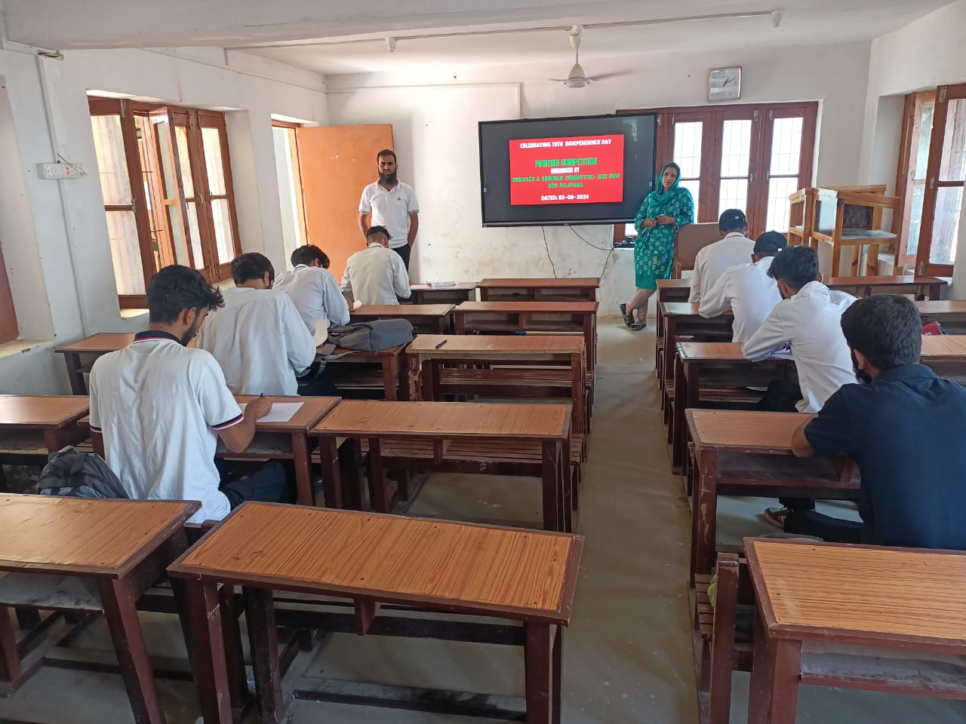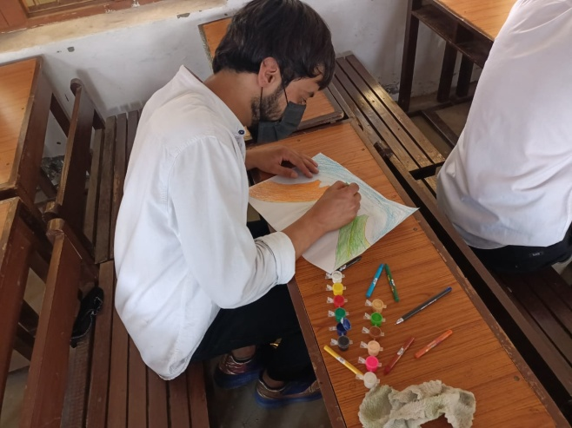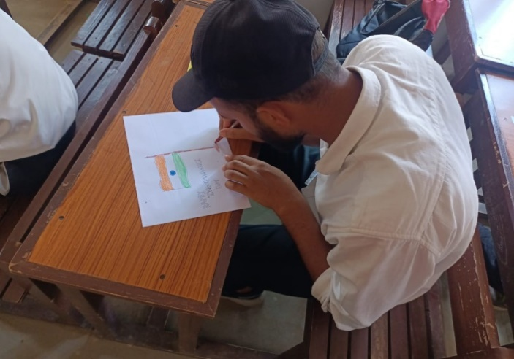

Convener Principal

Debates and Seminar Committee Govt. Degree college Rajpora

**Quiz Competition on “Freedom Struggle and National Heroes” held on 05-08-2024**

The Debates and Seminar Committee in collaborating with the NSS Unit and Cultural Committee Government Degree College Rajpora organized a Quiz Competition on the theme **“Freedom Struggle and National Heroes”** on 05-0802024. A good number of students took part in this quiz competition. The participants were divided into six groups. All participants actively participated in the quiz and gave answers of most of the questions posed to them. Prof Ramiz Raja, HoD Political Science conducted the quiz. At the end of the quiz, the group comprising of Mursaleen Shabir, Mehvish Qadir and Nauman was declared the winner of the quiz competition.

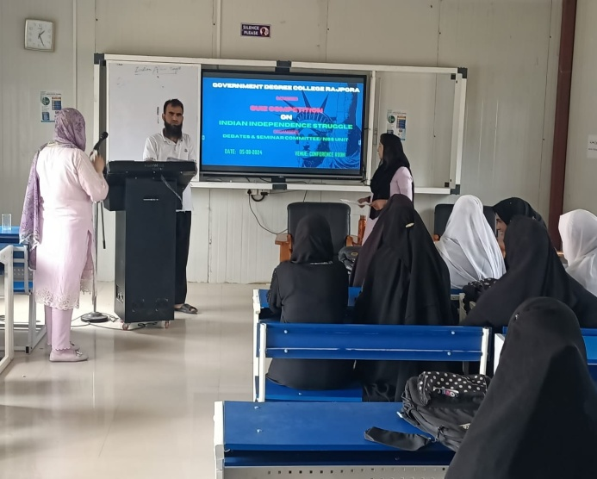 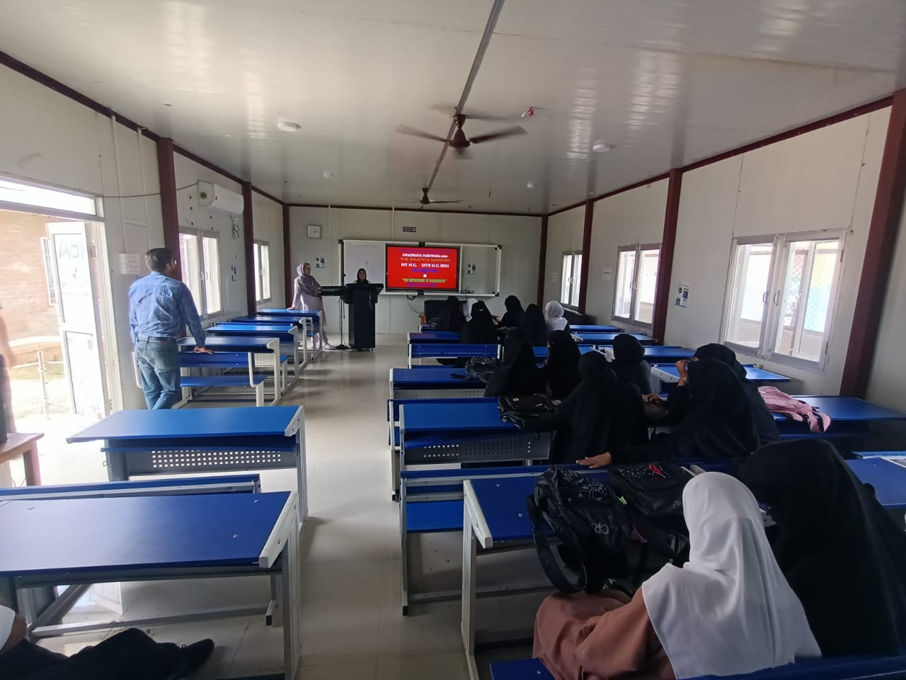

Convener Principal

Debates and Seminar Committee Govt. Degree college Rajpora

**Essay Writing Competition on “Unsung Heroes of Freedom Struggle”**

**held on 07-08-2024**

The Debates and Seminar Committee in collaborating with the NSS Unit of the College organized an essay writing Competition on the theme **“Unsung Heroes of Freedom Struggle”** on 07-0802024. A good number of students took part in this essay writing competition. The participants were given time duration to jot down their essays. All participants wrote very interesting essays. After evaluating the essays, Raziya Yousuf from 2nd semester was declared as the winner of first position of the essay competition.

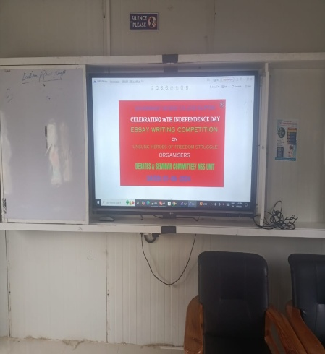 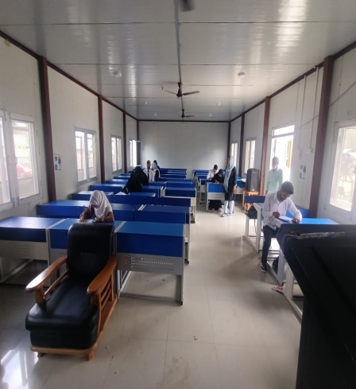

Convener Principal

Debates and Seminar Committee Govt. Degree college Rajpora