**Report on cleanliness drive inside classrooms on 07-08-2024**

As part of the Swachhta Pakhwada initiative, a cleanliness drive inside classrooms was organized by GDC Rajpora on 7 August 2024, focusing on maintaining and improving hygiene and cleanliness inside classrooms. The event aimed to create awareness about the importance of a clean environment in educational settings and to encourage students and staff to actively participate in cleanliness activities. It ensures a clean and healthy classroom environment for students and staff, raises awareness about the importance of cleanliness and hygiene, and fosters a sense of responsibility among the college community towards maintaining cleanliness.

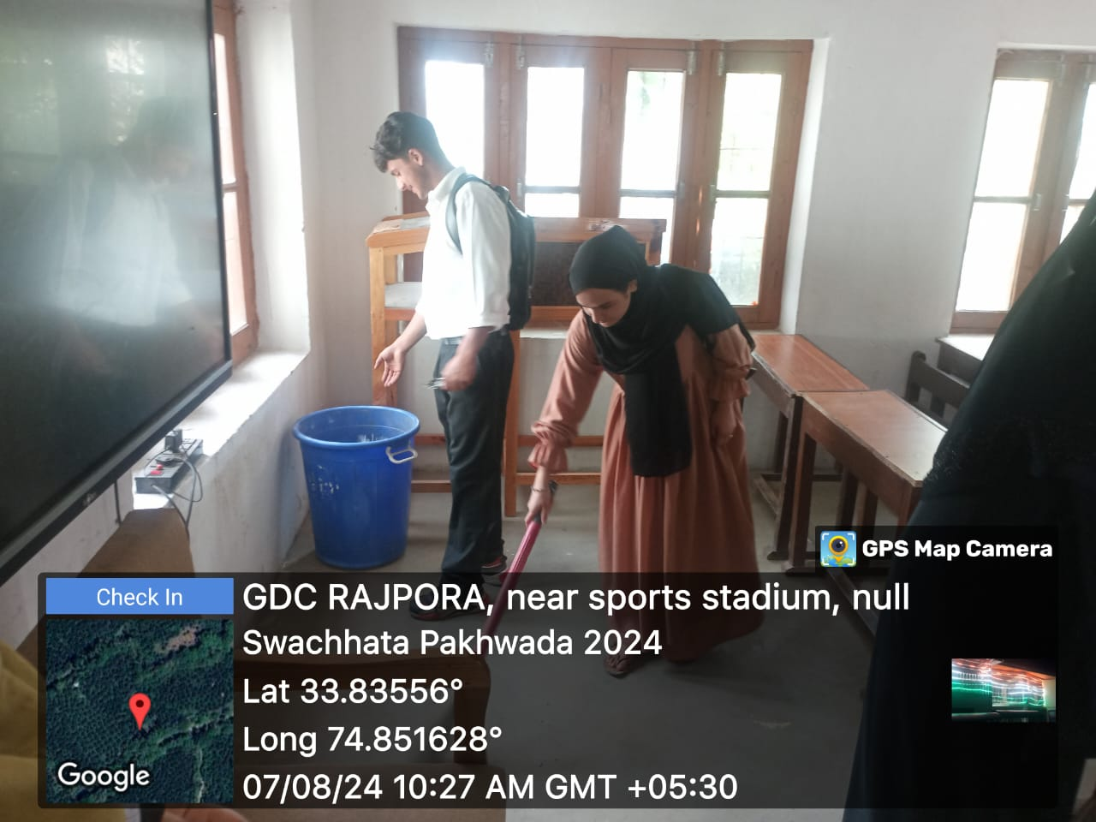 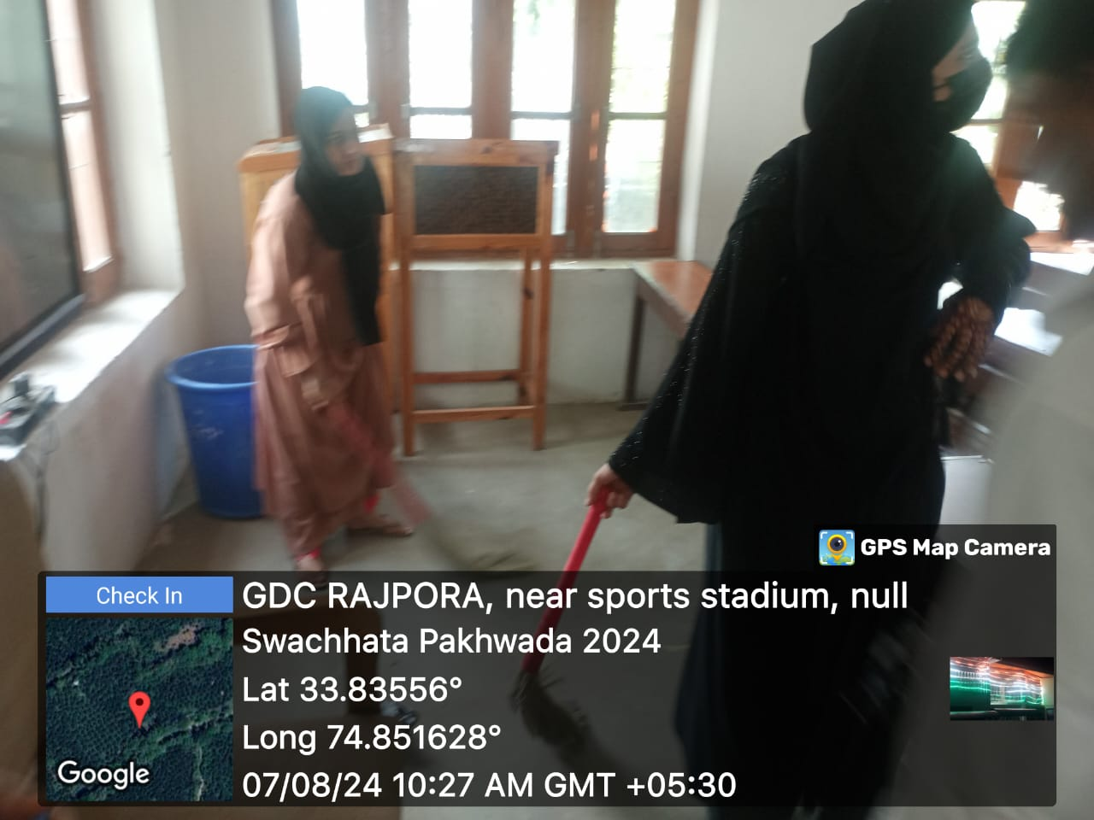

Nodal Officer Principal

Swachhata Pakhwada 2024 Govt. Degree College Rajpora